**6 System Models**

**6.1 Use Case Model**

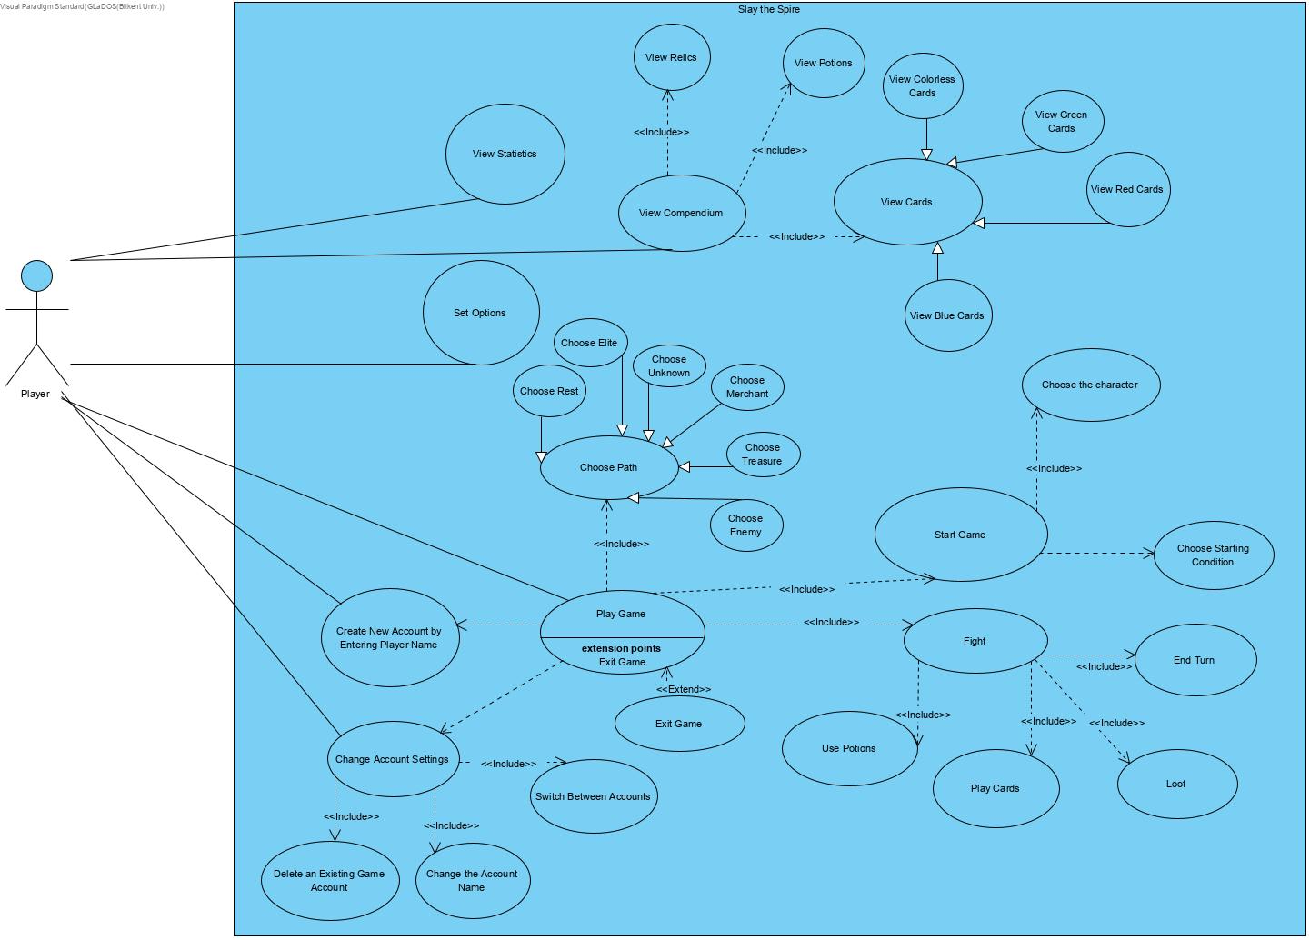

### **6.1.1 Use Case Descriptions**

**Use Case:** Play Game

**Participating Actor:** Player

**Flow of Events:**

1. The player starts game by choosing a character and selecting starting condition
2. The player continuously chooses path and makes decisions to go up the floors
3. The player fights by monsters with his choice of actions

**Entry Conditions:**

Player has already created an account by using Create New Account by Entering Player Name

Player clicks on the Play Game button

**Exit Conditions:**

Player is eliminated

Player wins by defeating final boss

Player saves its current progress and exits from the game

**Use Case:** Create New Account by Entering Player Name

**Participating Actor:** Player

**Flow of Events:** Player creates an account by entering an account name

**Entry Conditions:** Player clicks on the Create a New Account button

**Exit Conditions:** A newaccount has been created

**Use Case:**  Change Account Settings

**Participating Actor:** Player

**Flow of Events:**

1. Player selects an existing account
2. Player makes changes in his account

**Entry Conditions:** Player clicks on the Change Account Settings button

**Exit Conditions:** Player clicks on the Finish button

**Use Case:**  Delete An Existing Game Account

**Participating Actor:** Player

**Flow of Events:** Player deletes an existing account

**Entry Conditions:**

Player has an existing account

Player uses Change Account Settings

Player clicks on the Delete button

**Exit Conditions:**

The account is deleted

Player clicks on the Finish button

**Special Requirements:** Player cannot delete the account he/she logged in with

**Use Case:**  Change The Account Name

**Participating Actor:** Player

**Flow of Events:** Player enters a new name for the already existing account

**Entry Conditions:**

Player has an existing account

Player uses Change Account Settings

Player clicks on the Change Account Name button

**Exit Conditions:** The name account is changed

**Use Case:**  Switch Between Accounts

**Participating Actor:** Player

**Flow of Events:** Player chooses an account to login

**Entry Conditions:**

Player has two existing accounts

Player uses Change Account Settings

Player clicks on the Switch Account button

**Exit Conditions:** Current account is changed

**Use Case:** View Statistics

**Participating Actor:** Player

**Flow of Events:** Player views the recorded achievements and stats of his/her account

**Entry Conditions:** Player clicks on the View Statistics button

**Exit Conditions:** Player clicks on the Finish button

**Use Case:** Set Options

**Participating Actor:** Player

**Flow of Events:** Player creates new settings for the game

**Entry Conditions:** Player clicks on the Set Options button

**Exit Conditions:** Player clicks on the Finish button

**Use Case:** View Compendium

**Participating Actor:** Player

**Flow of Events:** Player selects to view relics, potions, cards in the compendium

**Entry Conditions:** Player clicks on the View Compendium button

**Exit Conditions:** Player clicks on the Finish button

**Use Case:** View Cards

**Participating Actor:** Player

**Flow of Events:** Player views his cards on the compendium

**Entry Conditions:**

Player uses View Compendium

Player clicks on the View Cards button

**Exit Conditions:** Player clicks on the Finish button

**Use Case:** View Colorless Cards

**Participating Actor:** Inheritedfrom View Cards use case

**Flow of Events:** Player views his colorless cards on the compendium

**Entry Conditions:** Inheritedfrom View Cards use case

**Exit Conditions:** Inheritedfrom View Cards use case

**Use Case:** View Red Cards

**Participating Actor:** Inheritedfrom View Cards use case

**Flow of Events:** Player views his red cards on the compendium

**Entry Conditions:** Inheritedfrom View Cards use case

**Exit Conditions:** Inheritedfrom View Cards use case

**Use Case:** View Blue Cards

**Participating Actor:** Inheritedfrom View Cards use case

**Flow of Events:** Player views his blue cards on the compendium

**Entry Conditions:** Inheritedfrom View Cards use case

**Exit Conditions:** Inheritedfrom View Cards use case

**Use Case:** View Green Cards

**Participating Actor:** Inheritedfrom View Cards use case

**Flow of Events:** Player views his green cards on the compendium

**Entry Conditions:** Inheritedfrom View Cards use case

**Exit Conditions:** Inheritedfrom View Cards use case

**Use Case:** View Relics

**Participating Actor:** Player

**Flow of Events:** Player views his relics on the compendium

**Entry Conditions:**

Player uses View Compendium

Player clicks on the View Relics button

**Exit Conditions:** Player clicks on the Finish button

**Use Case:** View Potions

**Participating Actor:** Player

**Flow of Events:** Player views his potions on the compendium

**Entry Conditions:**

Player uses View Compendium

Player clicks on the View Potions button

**Exit Conditions:** Player clicks on the Finish button

**Use Case:** Start Game

**Participating Actor:** Player

**Flow of Events:**

1. Player starts a new run
2. Player selects a character/characters by Choose the Character
3. Player decides starting conditions by Choose Starting Condition

**Entry Conditions:** Player uses Play Game

**Exit Conditions:** Player clicks on the Start Run button

**Use Case:** Choose the Character

**Participating Actor:** Player

**Flow of Events:** Player selects character(s)

**Entry Conditions:** Player uses Start Game

**Exit Conditions:** Player clicks on the Select Character button

**Use Case:** Choose Starting Condition

**Participating Actor:** Player

**Flow of Events:** Player answers the dialogue and decides the starting condition.

**Entry Conditions:** Player uses Start Game

**Exit Conditions:** Player clicks on the Start Run button

**Use Case:** Choose Path

**Participating Actor:** Player

**Flow of Events:**

1. Player continuously chooses paths
2. Player enters actions through the path
3. Player makes decisions according to actions

**Entry Conditions:**

Player uses Play Game

Player has already started a game by Start Game

**Exit Conditions:** Player clicks on the Save&Exit button

**Use Case:** Choose Rest

**Participating Actor:** Inheritedfrom Choose Path use case

**Flow of Events:**

1. Player chooses a rest node on the map
2. The character(s) of Player are healed and thus their HP increased or alternatively the cards of the character(s) are upgraded by blacksmith
3. Player continues to choose paths on the map

**Entry Conditions:** Inheritedfrom Choose Path use case

**Exit Conditions:** Inheritedfrom Choose Path use case

**Use Case:** Choose Elite

**Participating Actor:** Inheritedfrom Choose Path use case

**Flow of Events:**

1. Player chooses an elite node on the map
2. The character(s) managed by Player fights against an Elite type of an enemy.
3. According to the result of the fight, Player continues to choose paths on the map or the run is ended.

**Entry Conditions:** Inheritedfrom Choose Path use case

**Exit Conditions:** Inheritedfrom Choose Path use case

**Special Requirements:**

If during the fight, Player saves and exits, his progress in fight will not be saved

**Use Case:** Choose Unknown

**Participating Actor:** Inheritedfrom Choose Path use case

**Flow of Events:**

1. Player chooses an unknown node on the map
2. Among the actions merchant, enemy, elite or treasure, Player encounters with a random action or alternatively Player encounters with a random event where he/she is going to make choices and take their consequences
3. Player continues to choose paths on the map

**Entry Conditions:** Inheritedfrom Choose Path use case

**Exit Conditions:** Inheritedfrom Choose Path use case

**Special Requirements:**

If during the fight, Player saves and exits, his progress in fight will not be saved

**Use Case:** Choose Merchant

**Participating Actor:** Inheritedfrom Choose Path use case

**Flow of Events:**

1. Player chooses a merchant side on the map
2. With the current money, Player can purchases items, potions, cards and also can discard the unwanted cards inside the current deck(s)
3. Player continues to choose paths on the map

**Entry Conditions:** Inheritedfrom Choose Path use case

**Exit Conditions:** Inheritedfrom Choose Path use case

**Use Case:** Choose Treasure

**Participating Actor:** Inheritedfrom Choose Path use case

**Flow of Events:**

1. Player chooses a treasure node on the map
2. Player opens a treasure chest which may grant potion(s), relic(s), card(s) and money
3. Player continues to choose paths on the map

**Entry Conditions:** Inheritedfrom Choose Path use case

**Exit Conditions:** Inheritedfrom Choose Path use case

**Use Case:** Choose Enemy

**Participating Actor:** Inheritedfrom Choose Path use case

**Flow of Events:**

1. Player chooses an enemy node on the map
2. The character(s) managed by Player fights against an basic type of an enemy.
3. Player continues to choose paths on the map

**Entry Conditions:** Inheritedfrom Choose Path use case

**Exit Conditions:** Inheritedfrom Choose Path use case

**Special Requirements:**

If during the fight, Player saves and exits, his progress in fight will not be saved

**Use Case:** Fight

**Participating Actor:** Player

**Flow of Events:**

1. Player starts the fight
2. Player plays cards and potions to defeat the enemy
3. Player ends his/her turn
4. The enemy makes its predetermined action and ends its turn
5. The above sequence in the stages 2-4 continues until one side wins and other side loses
6. If Player is the winner, he/she can get the loot that includes money, card(s), relic(s), potion(s); otherwise, the run of Player might be terminated.
7. If Player has won the fight or has achieved to survive, he continues to select his path on the map by Choose Path

**Entry Conditions:**

Player uses Play Game

Player has already started a game by Start Game

**Exit Conditions:** Player clicks on the Save&Exit button

**Special Requirements:**

If during the fight, Player saves and exits, his progress in fight will not be saved

**Use Case:** Use Potions

**Participating Actor:** Player

**Flow of Events:** Player consumes potions in the fight

**Entry Conditions:** Player uses Fight

**Exit Conditions:** Player clicks on the Save&Exit button

**Use Case:** Play Cards

**Participating Actor:** Player

**Flow of Events:** Player play the cards of the characters

**Entry Conditions:**

Player uses Fight

The character(s) must possess enough action points (mana) in that turn as the desired card wants

The character(s) must have drawn the card from draw-pile

**Exit Conditions:** Player clicks on the Save&Exit button

**Use Case:** End Turn

**Participating Actor:** Player

**Flow of Events:** Player ends his/her turn after completing his/her actions

**Entry Conditions:** Player uses Fight

**Exit Conditions:** Player clicks on the Save&Exit button

**Use Case:** Loot

**Participating Actor:** Player

**Flow of Events:**

1. Player loots the goods such as money, relic, potion and card after winning the fight
2. Player continues to select the path by Choose Path

**Entry Conditions:**

Player uses Fight

Player should win the fight

**Exit Conditions:** Player clicks on the Save&Exit button

**Use Case:** Exit **extends** Play Game

**Participating Actor:** Player

**Flow of Events:** Player exits from Slay the Spire

**Entry Conditions:** Player clicks on the Exit button

**Exit Conditions:** None

### **6.2.2 Activity Diagrams**

### 

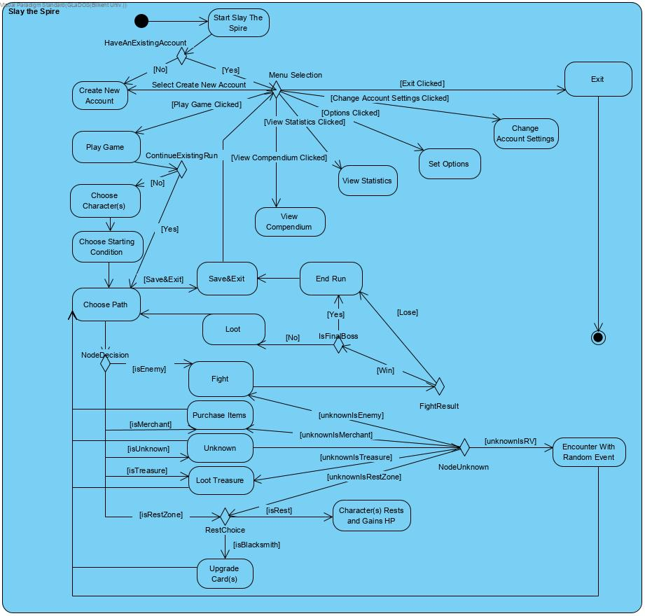

# 

# 

# **7. Glossary**

# **8. References**

**[1]“Slay the Spire Wiki,” *Fandom*. [Online]. Available: https://slay-the-spire.fandom.com/wiki/Slay_the_Spire_Wiki. [Accessed: 04-Mar-2020].**

**[2]*Balsamiq*. [Online]. Available: https://balsamiq.com/. [Accessed: 04-Mar-2020].**